**Part II: The Project Pitch**

**Style**

My Client has a real estate business called PakLands. The style of the website will be simple and eye-catching.

**Examples**

1. [Real Estate, Homes for Sale, Home Values, Agents and Advice | RE/MAX (remax.com)](https://www.remax.com/)
2. [Rightmove - UK's number one property website for properties for sale and to rent](https://www.rightmove.co.uk/)
3. [Real Estate, Homes for Sale, MLS Listings, Agents | Redfin](https://www.redfin.com/)

**Mock-up of Landing Page**

I have created a mock-up of the home page using a tool called figma.

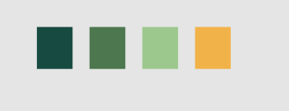

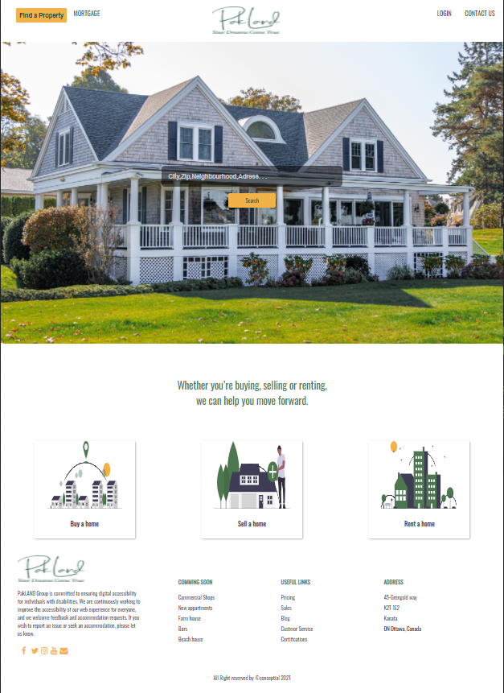

**Part III: The Style Guide**

**Client**

The client’s name is Khalid Toor and he owns a real estate business called PakLands. Mr.Toor is new to the real estate business society and is looking to creating a website for his business. He wants to have a website were the user can find a home to buy, rent or even sell.

**Style**

The style of the website is simple and soothing to the eye by using colours of nature, such as green, yellow, and grey. The colour should be not too bright, instead it should be close to nature so it can be easy on the eyes to find the perfect home.

**Platform**

The website will target traditional monitor resolutions of 1024X768 and greater. It will be responsive and accessible for all.

**Semantic Design Guide**

Head

* The expected use of that semantic element:
  + This is used to display the title of the page, and link the css, and any font styles.
* Names (id=) used for any generic block element containers (<div>)
  + Meta and title tags are used.
* Font choices used in that element
  + Google font is used
  + Font awesome has been linked in the head.
* Colour choices used in that element
  + Does not apply here
* Standard images required for element (ie. logos) and their sizes
  + Does not apply here
* Layout location for the element
  + This is the first element

Main

* The expected use of that semantic element:
  + All the code is inside the main.
* Names (id=) used for any generic block element containers (<div>)
  + Does not apply to this element
* Font choices used in that element
  + Does not apply to this element
* Colour choices used in that element
  + Does not apply to this element
* Standard images required for element (ie. logos) and their sizes
  + Does not apply to this element
* Layout location for the element
  + The main is inside the body.

Nav

* The expected use of that semantic element:
  + The nav is used to create the navigation bar with the links to all the pages.
* Names (id=) used for any generic block element containers (<div>)
  + Class “navbar” is used to control the navigation bar.
  + <ul> is used to create a list of all the pages on the nav bar. The
* Font choices used in that element
* Colour choices used in that element
  + Green and yellow are used. When you hover for a page the button changes to green. The Find a Home button is Yellow differentiate it from the rest of the pages.
* Standard images required for element (ie. logos) and their sizes
  + In the nav bar an image of the logo has been added. The size of the logo is 100px width by 200px height wise.
* Layout location for the element
  + The nav bar is inside the main element, and is the first element inside the main.
  + The nav bar is physically displayed at the top of the website.

Section

* The expected use of that semantic element:
  + Section is used to separate parts on a page.
* Names (id=) used for any generic block element containers (<div>)
  + Multiple containers are used inside of the section depending on which page you are on. If you take the index.html page as an example, it has a div with a class “background” that displays the main splash image with a search bar.
  + Also, in the index.html page under the section element we have a <div> with a class called “cards”. The Cards class displays the three cards that display on the page that take you to the Buy, Rent, and Sell pages.
* Font choices used in that element
* Colour choices used in that element
  + Green, yellow and grey are used. For example in the index.html page the main slogan after the splash image is in green.
  + The cards have images that use the same colour scheme of green, yellow and grey.
  + The cards have yellow buttons.
* Standard images required for element (ie. logos) and their sizes
  + On the index page this element has a splash image, and the cards have images of different homes to represent But, sell, rent.
* Layout location for the element
  + The section element is after the nav bar because this is the bulk of the content of the page.

Form

* The expected use of that semantic element:
  + The purpose of a form is to fill out information. In our case the form is used on the contactus.html page to get the name, email and concern of the user, which is opens up an email with the email address of the business.
* Names (id=) used for any generic block element containers (<div>)
  + The form has a mailto action.
  + It has a class of ‘inputbox’ where it regulates the inputs. If an input is not filled it will indicate to fill it, and that you cannot leave it empty.
* Font choices used in that element
* Colour choices used in that element
  + Grey, green, yellow are used, with white text. The grey is used for the colour of the form. The yellow is used for the buttons and the circle for the icons for the contact information.
  + Green is used for the icons, and for the text in the button.
  + The rest of the text is white to give some contrast.
* Standard images required for element (ie. logos) and their sizes
  + A background image is used the size of the image is to fill the background.
* Layout location for the element
  + The form element is inside the sections element.

Table

* The expected use of that semantic element:
  + The table is used to organize the features of a house, and to indicate if the feature is include or not. You can find the table under buy, rent, and sell pages when you hover over one of the listings.
* Names (id=) used for any generic block element containers (<div>)
* Font choices used in that element
* Colour choices used in that element
  + The price and title of the table are green, whereas the background of the table is grey.
* Standard images required for element (ie. logos) and their sizes

No images used in the table.

* Layout location for the element
  + This element is inside the section element on buy, rent, and sell page.

Footer

* The expected use of that semantic element:
  + The footer is used to provide important links, address of the business, and what is coming up soon.
* Names (id=) used for any generic block element containers (<div>)
  + The footer includes a “socials” class which organizes all the media icons and links
  + The footer has a “logo-footer” class which aligns the logo
* Font choices used in that element
* Colour choices used in that element
  + All the headings have a green colour whereas the text is black. The media icons are yellow to give some contrast while still sticking to the theme.
* Standard images required for element (ie. logos) and their sizes
  + The logo image has been added with a size of 200px by 80px.
* Layout location for the element
  + This is the last element inside the <main>.

**Website Map**

